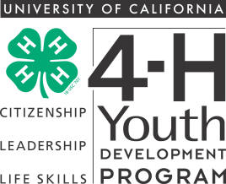

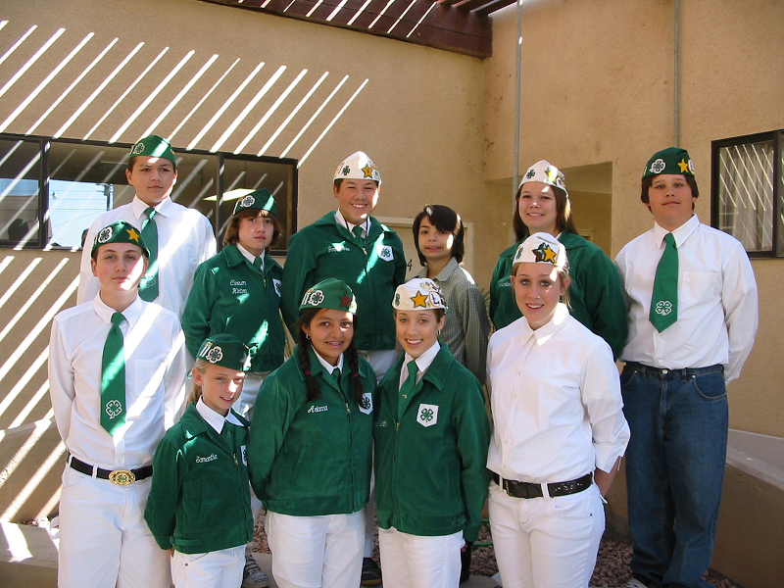

MAY 2008

Calendar of Events

May
01 – Leaders Council Meeting – 7:00p.m
15 – Livestock Leaders Meeting – 7:00pm.
21 – Scholarship Apps. Due
31 – State 4-H Field Day

June
06 – Calendar Planning
28 – Record Book Judging

July
11 – 13 – Family Camp
31 – State Leadership Conf.

August
01 – 03 – cont. State Leadership Conf.



INTERCOM

Leaders Council Meeting 2
Livestock Leaders Meeting 2
A Well Deserved Thanks 2
Scholarship Application 3
Still Life Showmanship Results 4
Presentation Day Results 4
Garden Delights Results 5
Summer Leadership 5
Fashion Revue Results 6
Record Book Round-Up 7
Summer Camp 8

MAY LEADERS COUNCIL MEETING

This is the last regular meeting of the ‘07-‘08 year. Budget and election of new officers will top the agenda. Additionally, community club leaders will discuss State Leadership conference, Summer Family Camp, Council scholarships and Record Book judging.

Let’s plan to be “GREAT IN ‘08”!! To that end, Council leadership has scheduled an additional June meeting. County calendar of events for members and training sessions for leaders will be set at that time. The June meeting will start at 6pm with light dinner and beverages provided.

A WELL DESERVED THANK YOU…

A 4-H Leader writes: “Thank you to Charlie Borchard for making the California Mid-Winter Fair and Fiesta what it is, for being the first one there in the morning and the last one there at night. To his family for sharing him with the rest of the valley and you rarely getting to see him when he has to put the fair first. For doing the best job you can and making the California Mid-Winter Fair the best you can make it and not caring who criticizes you whether they appreciate what you do or not because you are looking out for the best interests of the Imperial Valley and its community to have a fun and profitable fair.”

MAY LIVESTOCK LEADERS COMMITTEE MEETING

CHANGE OF DATE: New date is Wednesday, May 14, 2008, 7pm, Farm Bureau Auditorium. (Change of date was necessitated by meeting site conflict.)

Agenda items to include plans for 2008 project leader training, and utilization of county resource leader model.





ATTENTION ALL GRADUATING SENIORS!!!

The 4-H Leaders Council is offering six (6) $250 scholarships to 4-H graduating seniors, class of 2008. Please write a letter to the 4-H Scholarship Committee concerning your plans for the future, your reasons for wanting to continue your education, your plans to attend a community college, trade school or a four-year university, what 4-H has meant to you and the reason why you would like the scholarship.

The scholarship application is attached to this month’s Intercom and is due to 4-H office no later than May 21, 2008. Application, essay, current 2007 record book, high school transcript and a letter of recommendation from a 4-H leader are all that are required; no personal interview will be necessary.

Pre-requisite: Graduating seniors currently enrolled in the 4-H Program.

6 - $250.00 scholarships to be awarded.

NAME________________________________________ AGE____________________________

ADDRESS______________________________________________________________________________

CLUB__________________________________________________________________________________

Where do you plan to continue your education?_________________________________________________

_______________________________________________________________________________________

_______________________________________________________________________________________

Attach the following:

- A letter to the 4-H Scholarship Committee concerning your plans for the future, your reasons for wanting to continue your education, what 4-H has meant to you, and the reason you would like to be awarded this scholarship. Include any information concerning your leadership and any other pertinent facts. The letter should be legible and either typed or written in ink.
- Current record book.
- Current transcript from your school.
- Letter of recommendation from a 4-H leader.

Note: Application must be turned into the 4-H Office by May 21st.

2008 STILL LIFE SHOWMANSHIP RESULTS

Primary:
Laneesha James – Star Route
Junior Novice:
County Winner - Leesha James
Star Route
Intermediate Novice:
County Winner - CJ Lopez
Star Route
Medalist - Jonathan Finnell
United Valley
Intermediate:
County Winner - Samantha Holimon
Star Route
Senior:
County Winner - Jordan Yee
United Valley

PRESENTATION DAY 2008
RESULTS

Educational Exhibits:
Cole Dammarell – United Valley
Blue Ribbon
Matthew Jones – Star Route -Gold Ribbon - Intermediate Champion
Christina Dammarell – United Valley Gold Ribbon
Jordan Yee – United Valley –
Blue Ribbon
Jeanine Smith – Star Route –
Gold Ribbon - Senior Champion

Impromptu:
CJ Lopez – Star Route - Blue Ribbon - Intermediate Champion

Presentations:
Leesha James – Star Route -
Gold Ribbon, Junior Champion
Gabbee Lofton – Star Route –
Gold Ribbon
CJ Lopez – Star Route - Gold Ribbon
Sammy Holiman – Star Route –
Gold Ribbon, Intermediate Champion
Josh Klockman – M & M

Audio/Visual Presentations:
Jonathan Finnell – United Valley
Gold Ribbon, Intermediate Champion
Christina Dammarell – United Valley
Gold Ribbon, Senior Champion

Cultural Arts:
“Sign Singing” by Caleigh & Christina Dammarell – United Valley



Garden Delights was held Tuesday, April 15, 2008 at Cornerstone Church in Holtville. Hosted by Verde 4-H, four clubs were represented, with 22 adults as spectators. Guest presenter was Nancy Robinson from the UC Desert Research Extension Center. The results are as follows:

Special Occasion:
Primary Participation ribbon Caleigh Dammarell United Valley
Primary Participation ribbon Caryssa Dammarell United Valley

6th, 7th, 8th County Winner Matthew Jones Star Route

9th-12th County Winner Jordan Yee United Valley

Formal:
9th-12th County Winner Josh Klockmann M&M

Informal:

Primary Participation ribbon Leah Yee United Valley

9-12th County Winner William Young M &M
Medalist Christina Dammarell United Valley

GARDEN DELIGHTS RESULTS

CALLING 4-H TEENS LEADERS
SUMMER LEADERSHIP OPPORTUNITIES

Imperial County 4-H will again host a Summer Day Camp, sponsored by the Imperial Valley Housing Authority. It will last four weeks during July, 2008 and will be conducted at the Housing Authority sites for youth living in those facilities.

Older 4-H members (high school age) who want valuable experience working with youth of all ages and abilities should contact the 4-H Office. Small stipends are available to those teens committing to the program for an extended period of time. Projects to be taught include arts and crafts, electricity, woodworking, needlecraft, dance, etc. Contact the 4-H Office for more information.




2008 IMPERIAL COUNTY 4-H FASHION REVUE RESULTS
April 6, 2008

Super Structure
Junior
County Winner – Caitlin McConnell - Family
1st Medalist – Destiny Kalin - Family
2nd Medalist - Aucktavea Odell - Family
Intermediate
County Winner – Marizela Perez - Family
1st Medalist – Victoria McConnell - Family
2nd Medalist – Jessie Dunkin - Family
Senior
County Winner – Stephanie Torres - Family
1st Medalist – Veronica Lopez - Family
2nd Medalist – Selene Sheets - Family
Traditional
Primary Recognition
Brittany Garcia – Family
Junior Novice
County Winner – Emma Sheets – Family
1st Medalist – Aucktavea Odell – Family
2nd Medalist – Genesis Partida
Junior
County Winner – Caitlin McConnell – Family
1st Medalist – Destiny Kalin - Family
Caitlin McConnell – Family
Intermediate Novice
County Winner - Jessie Dunkin - Family
1st Medalist – Gisenia Velasquez
Intermediate
County Winner – Marizela Perez - Family
1st Medalist – Victoria McConnell - Family
2nd Medalist – Samantha Holiman – Star Route
Marizela Perez – Family
Senior Novice
County Winner – Melanie Partida - Family
1st Medalist – Stephanie Torres - Family
2nd Medalist – Veronica Lopez – Family
Senior
County Winner – Selene Sheets – Family
Selene Sheets – Family
Recycled
Intermediate
County Winner - Samantha Holiman – Star Route
Samantha Holiman – Star Route

Hosted By Family and Star Route 4-H Clubs



Wearable Art
Primary Recognition
Cana Schouder – Star Route
Intermediate
County Winner - Samantha Holiman – Star Route
Samantha Holiman – Star Route
Purchase
Primary Recognition
Laneesha James– Star Route
Junior Novice
County Winner - Leesha James – Star Route
Leesha James – Star Route
Intermediate Novice
County Winner – C.J. Lopez – Star Route
1st Medalist – Marizela Perez
Intermediate
County Winner - Samantha Holiman – Star Route
C.J. Lopez – Star Route

2008 Backpack Challenge
Intermediate
County Winner - Samantha Holiman – Star Route
Samantha Holiman – Star Route

Modeling Awards
Junior Novice
Leesha James – Star Route
Junior
Destiny Kalin – Family
Intermediate Novice
C.J. Lopez – Star Route
Intermediate
Samantha Holiman – Star Route
Senior Novice
Stephanie Torres – Family
Senior
Selene Sheets – Family

Thanks to Linda Hamby, Rita Harvey, Marjorie Monte, Mary Ann Smith. 2007-2008 Imperial County All Stars: Naomi Klockmann and Jeanine Smith. Special Thanks to the Westmorland Community Presbyterian Church for the use of their facility.

RECORD BOOK ROUND UP

The areas of Personal Development Record (PDR) are as follows:
1. 4-H Projects Completed
2. 4-H Project Skills Activities
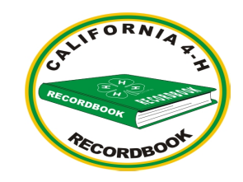
3. 4-H events attended
4. Leadership Development
5. Citizenship
6. Communication Skills
7. Honors and Recognition
8. Lifestyle Activities

February 16th Fair Clean Up Day #1
(This is a category that could actually count in several places depending on where you need the credit. You can only count it once.)
Counts under the following:
#3 – If you attended the clean up day
#4 – If you attended the clean up day
#5 – If you helped clean up

February 23 – Fair Clean Up Day #2
Counts under the following:
#4 – If you were on the barn decorations committee
#4 – If you were on the Landscaping contest committee
#5 – If you helped another club with their decorations or landscaping
#7 – If your club won a landscaping award

March 1st Fair!!!
Counts under the following:
#2 – If you exhibited your animal or still exhibit or did showmanship at the fair (count each project exhibited or each animal species that you did showmanship in), If you exhibited your animal at the Petting Zoo.
#3 – If you attended the fair but did not participate only watched.
#4 – If you are a junior/teen leader, If you were on the Petting Zoo committee, fair potluck committee, etc.
#6 – If you helped other members in learning species for round robin.
#7 – If won an award either your animal, still exhibit or your showmanship award. Also make sure to include your Round Robin winnings here.

April 5, - Presentation Day
Counts under the following:
#2 – If you exhibited an educational display
#3 – If you attended and did not participate
#4 – If you were on the committee to organize the event
#6 – If you did a presentation, Illustrated talk, Impromptu speech, etc., or it you were a room monitor
#7 – List any awards that you won

RECORD BOOKS ARE DUE:
JUNE 28, 2008 BY 9:00A.M.






2008 4-H Family
Camp-Out
Other
Day:
Contact Telephone #
Family Contact Person
4-H Club
Family Members/Age
Attending Camp

