

June 2008

2008 STATE LEADERSHIP CONFERENCE
IMPERIAL COUNTY 4-H INTERCOM
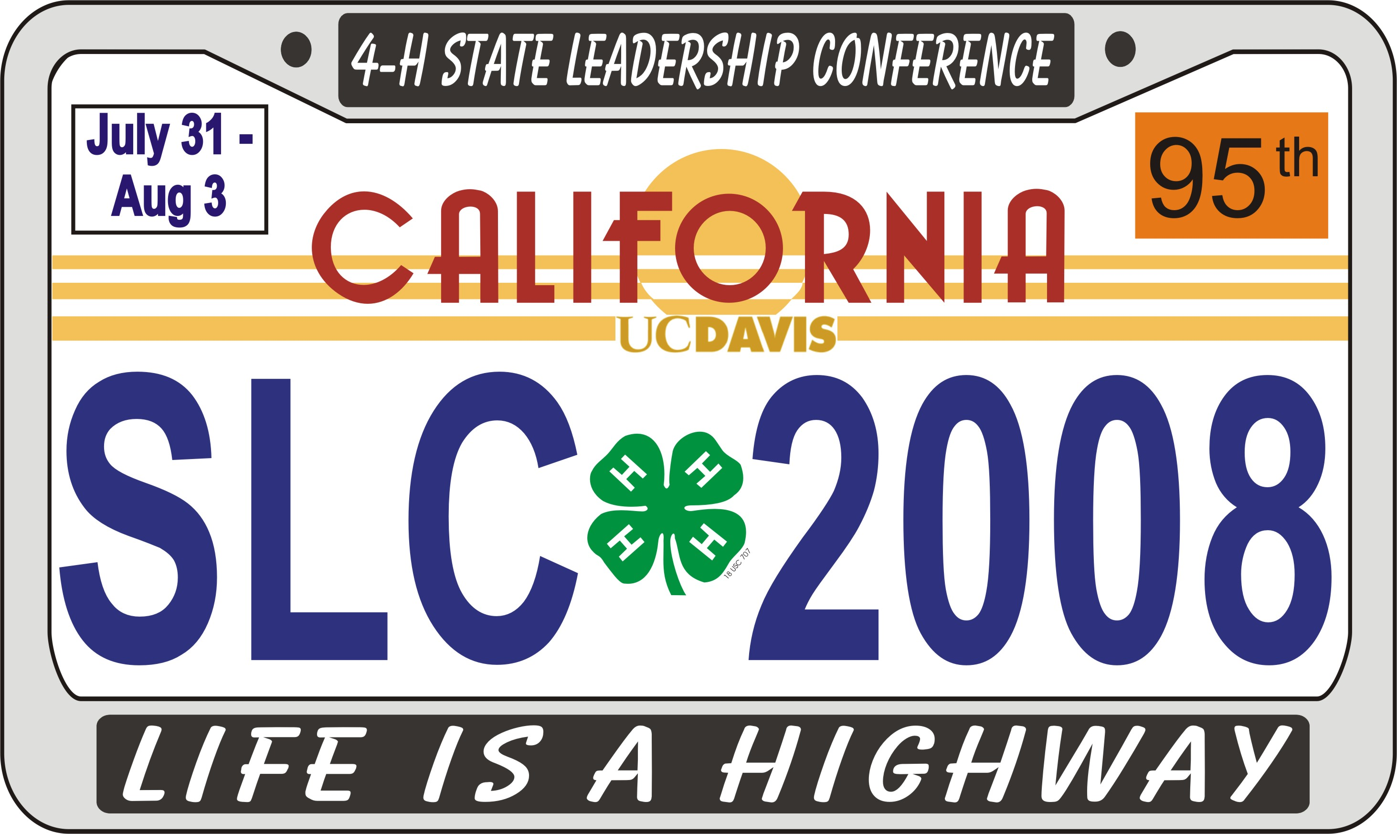
WHO: All 4-H members & families
WHEN: July 11 – 13, 2008
WHERE: Lake Morena – San Diego County Park
CABINS - $45.00 (Includes: cabin, food & activities)
TENTS - $35.00 (Includes: tent space, food & activities)
RV’s - $35.00 (Includes: food & activities) must call 1-877-565-3600 for RV reservations. Cost is separate for RV space.

2008 4-H FAMILY CAMP

RECORD BOOK JUDGING
Books are due Saturday, June 28, 2008 by 9am to the 4-H office.

Record Books are first evaluated at the club level and community leaders should check for completeness, signatures and order of records.

For forms and information, go to
http:// ceimperial.ucdavis.edu and follow the links to 4-H Program and then Record Books.

You will find there the Imperial County 4-H Award Application and 4-H Achievement Award. Excerpts from the State 4-H Record Book Manual are included on our county website as well. Important pages to read include “Formatting Instructions”, “Organization Overview” and “Section 1: Preliminary Information”.

The annual State Leadership Conference is a 4-day affair for older teens to learn leadership skills, meet other teens from around the county and state and discover exciting 4-H opportunities they might otherwise not learn about.

Community clubs are encouraged to sponsor their older members to attend this educational and fun event. They are sure to come back with ideas and increased enthusiasm for the 4-H program!! Invest in your teen leaders!! Fundraisers may also be undertaken to cover the cost of attendance and transportation.

This year’s conference is being held July 31-August 3, 2008 at UC Davis. Registration materials are due June 13, 2008. More information about the Conference is available at http://www.ca4h.org/conference/slc/index.asp

The University of California prohibits discrimination or harassment of any person on the basis of race, color, national origin, religion, sex, gender identity, pregnancy (including childbirth, and medical conditions related to pregnancy or childbirth), physical or mental disability, medical condition (cancer-related or genetic characteristics), ancestry, marital status, age, sexual orientation, citizenship, or status as a covered veteran (covered veterans are special disabled veterans, recently separated veterans, Vietnam era veterans, or any other veterans who served on active duty during a war or in a campaign or expedition for which a campaign badge has been authorized) in any of its programs or activities.

University policy is intended to be consistent with the provisions of applicable State and Federal laws.

Inquiries regarding the University’s nondiscrimination policies may be directed to the Affirmative Action/Staff Personnel Services Director, University of California, Agriculture and Natural Resources, 300 Lakeside Dr., 6th Floor, Oakland, CA 94612-3550, (510) 987-0096.
To simplify information, trade names of products may have been used but no endorsement of named product is intended, nor is criticism implied of similar product, which are not mentioned.

Cooperative Extension Work in Agriculture and Home Economics U.S. Department of Agriculture, University of California, and County of Imperial Cooperating.

For more information and reservation forms please call 352-9474.

UPCOMING EVENTS

June
06 – Calendar Planning – 6:00p.m.
Farm Bureau, light dinner provided
28 – Record Book Judging

July
11-13 – Family Camp
31 – State Leadership Conf.

August
01-03 – State Leadership Conf.





Visit website for more in depth information
http://ceimperial.ucdavis.edu


Monday
Today we are learning about dinosaurs.
Tuesday
Today we are learning about pets.
Wednesday
Today we are learning about the solar system.
Thursday
Today we are going on a field trip to the zoo.
Friday
Today we have a special guest from the fire department to tell us about fire safety.

Ms. Stahl’s Classroom Newsletter Page 2

Upcoming Events
Classroom Open House
Tuesday, September 6, 7:30 P.M.
Ice Cream Social with the Faculty
Friday, September 9, 5 P.M.
School Assembly
This week's school assembly is on storybook characters. Children may dress up like a character on Thursday. (You might want to bring a change of clothes for the rest of the day.) Costumes can be as simple as a hat or a small picture of your character pinned to your shirt. Have fun.

Reminders to Students
- Bring money for field trip lunch
- Bring umbrella in case it rains
- Think of a costume for Friday’s assembly

Reminders to Parents
Your child will need the following supplies this year:
- backpack
- 3 spiral notebooks
- 1 box of pencils
- erasers
- rulers
- compass
- lunch box

Thank You Students!
Special thanks are due the following students:
Jay Adams for volunteering to clean up after the fall open house.
Kari Hensien for donating her checkers set to recess.
Alan Shen for baking us his grandmother's chocolate chip cookies last week.
Thank you also to Ms. Brown for bringing in the travel posters to decorate for open house.
This week in Science we will be studying animals, including dinosaurs and pets, as well as astronomy. Children will be required to complete an in-depth science report on the animal of their choice by next Wednesday morning. Our trip to the zoo on Thursday may inspire some creative choices!
We will also work on geometry problems in Math homework. In Social Studies, we will read a book about the culture of the Inuit people, who used to be called Eskimos.



This Week’s Assignments

This Week’s Highlights

