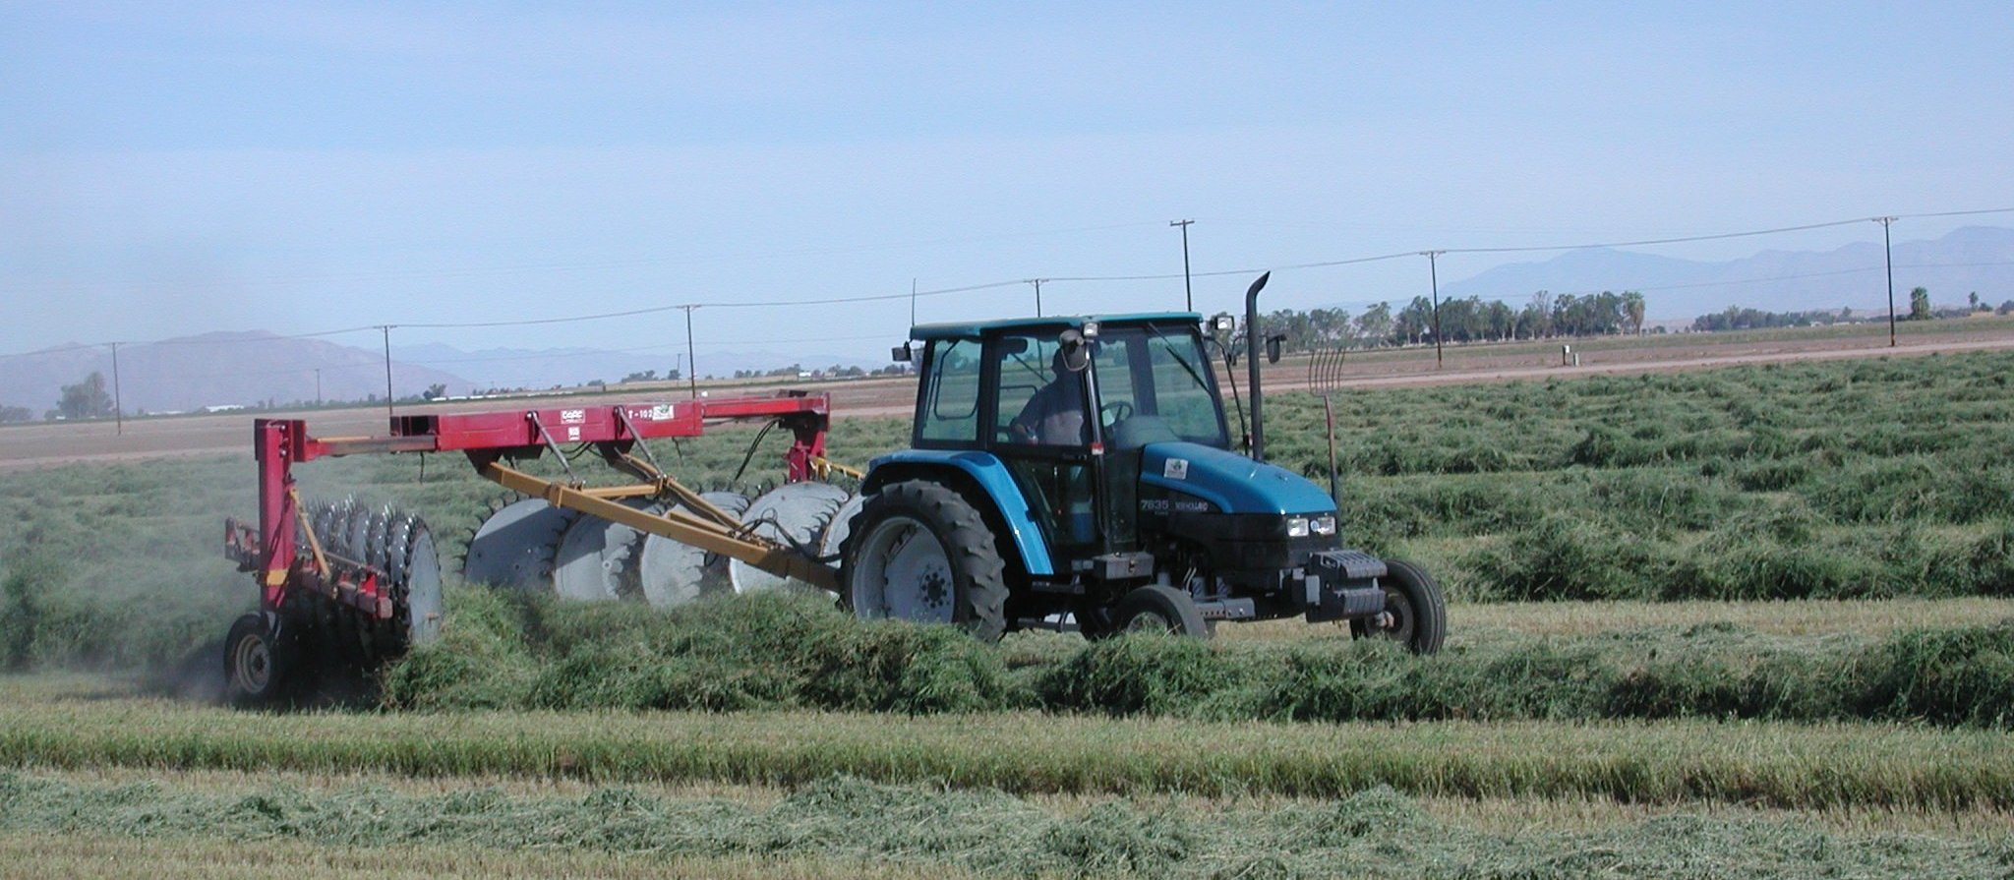
Imperial County Agricultural Briefs

From your Farm Advisors
Features

July 2005
 | Page
ADDING WATER TO DRY HAY ………………………….........………………..………… Juan N. Guerrero | 2
LYGUS BUG MANAGEMENT IN ALFALFA SEED PRODUCTION …............................. Eric T. Natwick | 3
LOCATION OF REDDENING ON COTTON PLANTS IS CLUE TO CAUSE .............. Michael Rethwisch | 4
SOIL-BORNE DISEASES AND CROP ROTATION CHOICES ……………...………….. Thomas A. Turini | 5
EFFICIENCY OF SPRINKLER IRRIGATION SYSTEMS …………………………………….. Khaled Bali | 6
STINK BUG MONITORING IN COTTON…………………………………………………… Eric T. Natwick | 7
HIGH TEMPERATURES LEAD TO ABNORMAL JUNE COTTON FLOWERS…….. Michael Rethwisch | 8
CIMIS REPORT .......................................................................................................Khaled Bali and Steve Burch | 9

Adding Water to Dry Hay

Juan N. Guerrero

Livestock do not like to eat dry, brittle hay. Hay stored all summer or year old hay often is fed to livestock. This type of hay is extremely dry, often having 5% moisture or less. This kind of dry, brittle hay can cut the inside of a horse’s or steer’s mouth. Many persons feed this type of hay because it is cheap to purchase. Besides the fact that this hay is less nutritious to feed, it is also unpalatable to livestock, as well.

Can this kind of hay be used at all? Yes, it can, with some care. Livestock prefer to eat soft, green hay. The preferred hay moisture range for livestock is 18 to 22%. Over 20% moisture hay may mold and at 22% moisture molding is very probable. At about 12% hay starts to be brittle. Hay stored roadside in May at 18% moisture, by October dries to about 5% or less. How do you make dry, brittle hay soft? The answer is, add water.

2

Water may be added in two ways. You may add the water directly to the bale, then let the bale equilibrate (let the moisture spread throughout the bale) for about 4 to 6 hours. This softened bale may then be broken and fed as “flakes” or ground (preferable). Water may be added to ground hay, mixed, equilibrated, and then fed. Once water has been added to hay, feed all the rewetted hay during the same day. Do not store rewetted hay.
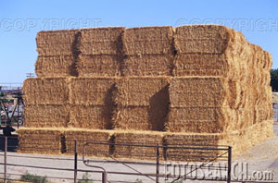

Below is a table that you might use in adding water to dry hay. Do not rewet to more than 24% moisture. Less than 10% moisture is too dry. Again, the optimal moisture range for hay palatability is about 18-22%.

Table 1. Gallons of water to add to one ton of dry hay.

Actual Hay Desired Hay moisture percentage
Moisture % 24 22 20 18 16 14 12 10
10 44 37 30 23 17 11 5
9 47 40 33 26 20 14 8
8 50 43 36 29 23 17 11 5
7 54 46 39 32 26 20 14 8
6 57 49 42 35 29 22 16 11
5 60 52 45 38 31 25 19 13
4 63 55 48 41 34 29 22 16

Lygus Bug Management in Alfalfa Seed Production

Eric T. Natwick

Lygus bug is the most important insect pest affecting production of alfalfa seed and it is vitally important that proper timing of insecticides treatments are based on realistic treatment levels. Proper timing of insecticides helps to minimizes pest control costs and essential in successful control of lygus bug. To control lygus bug we must understand the biology of this pest.

During the summer, it takes about 28 days for lygus bugs to complete their lifecycle. Insecticides applications must be timed to coincide with egg hatch and stage of development to achieve maximum lygus bug control. Lygus bugs are most easily controlled as nymphs to the third instar. Older nymphs are more difficult to control, especially fifth instar nymphs. It is not uncommon to find fourth and fifth instar nymphs and adults in alfalfa seed production fields after an insecticide treatment. Adults are strong fliers and will often be
repelled from seed production fields following an insecticide application, but adult can quickly return when the repellency has subsided.
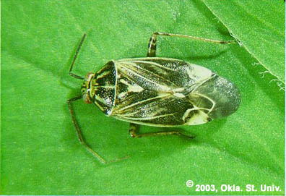

Withhold insecticide application when newly hatched first instar nymphs are observed in the field to allow all eggs to hatch. Percentages of control are improved when all lygus bug eggs have hatched and some nymphs have developed to the third instar. Lygus bug nymphs hatching a few days after an insecticide application often survive and an additional insecticide treatment may be necessary.

The first lygus bug insecticide treatment should be applied when a population of 4 to 6 bugs per sweep is reached during the period of early bloom when many buds are vulnerable to attack. During full bloom and seed set, treatment is suggested at 8 to 10 bugs per sweep. Later in the season, when the crop begins to mature, the suggested treatment level is 10 to 12 bugs per sweep. These guidelines are suggested action levels and are not necessarily fixed, but can vary with field condition.

Lygus bugs levels of 8 to 10 bugs per sweep during bloom and seed set usually do not adversely affect seed yield or quality and can be tolerated without economic loss. Fewer insecticide applications and less frequent disturbance to pollinator activity can be achieved by extending treatment intervals following the suggested action thresholds.

3

Location of Reddening on Cotton Plants is Clue to Cause

Michael Rethwisch

A number of cotton fields in the low desert during July 2004 exhibited reddening of foliage, with some plants further exhibiting severe wilt and lack of further growth. Cotton varieties that exhibited these symptoms were usually early planted, and had a very high boll load.

A recent report about K fertilization of cotton in the 2002 Better Crops with Plant Foods (No. 4) noted the following: "Fast fruiting cotton cultivars grown on loess-derived soils in states of the Mississippi River Valley commonly display K deficiencies during boll filling, despite the apparent adequacy of soil K. Potassium deficiency symptoms commonly appear in older leaf tissue as K is a mobile element and rapidly trans-located to young tissue and other sinks. However, in fast fruiting cultivars, they first appear in younger leaf tissue, indicating that K requirements exceed plant uptake. The high K demand during boll filling is indicative of the importance of this essential nutrient in the development of the fruiting body. Indeed, the boll contains approximately 60% of all K accumulated in the plant. A K deficiency during this critical stage of development affects both yield and quality of cotton fiber".

In most local cases, cotton with these symptoms are early planted varieties. The weather in 2004 was very conducive to high retention rates/heavy fruit loads. It appears as if K could be a limiting factor, but local soils do not contain vermiculite which can tie up soil K and data derived from other agricultural areas may or may not hold true here. As our heat units in the low desert accumulate at a much higher rate than many other locations, it seems reasonable and

highly likely that K short term deficiency could be occurring here as well, and with a higher boll load could also have higher short term K needs. It has not been proven that only a short term K deficiency is involved however, as K is related to almost every plant physiological function and other nutritional elements may in turn be affected.

In 2004 cotton plants also were infested with Empoasca (potato leafhopper complex) spp. that necessitated treatments for their control. Leafhoppers were at high enough levels to cause cotton foliage to turn red in late July and August, but plants did not exhibit wilt.
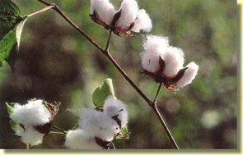

What should be examined?
Probably the best way is to check for early induced K deficiency is to examine the bracts on bolls. Each cotton boll has three bracts located at the boll base and these bracts have previously shielded the developing square/flower. Induced potassium deficiency will first appear in the bracts of bolls as potassium is trans-located into contiguous bolls, then will be further expressed in newer foliage

With Empoasca spp. leafhoppers, the newer foliage will be reddened, but the bracts will probably not be affected. Leafhoppers will also be present (unless they have been controlled) and veins will develop irregular lumps.

4

Soil-borne diseases and Crop Rotation Choices

Tom Turini

Most crops grown in the Imperial Valley are planted and harvested within a year. This may provide an opportunity for a grower to avoid a situation in which there is a risk of substantial crop damage due to soil borne pathogens or nematodes.

Commonly, a grower will plant a vegetable such as lettuce; then, a crop such as wheat or sudangrass. The field may then be planted once again to lettuce, then to the same crop sequence over and over again. How long should a rotation like this be continued? Perhaps it will never be necessary to abandon lettuce as a rotation crop on a specific field However, after years of lettuce production, soil-borne pathogens, such as Sclerotinia sclerotiorum and/or S. minor Fusarium oxysporum f. sp. lactucum and Lettuce big vein, can reach levels at which they can cause crop damage.

The same is true for many other crops. The need to rotate away from specific crops for an extended period of time is frequently due to the occurrence of disease and/or nematode problems. Some soil borne diseases can be extremely long lived.

Some crops are hosts for soil borne diseases that show few or no symptoms on them. However, the disease may be a major problem for a susceptible crop. A prime example of this is pink root of onion caused by Phoma terrestris, which can live on wheat without causing damage, but can virtually destroy a pink root susceptible onion variety.

Multi-textured fields may be a problem for some rotation crops. For example, a field may be grown to melons and cereals for years with no evident problem due to soil

5
texture. However, when planted to carrots the multi-texture changes from sandy to clayey areas can result in a problem. Areas may develop cavity spot disease caused by Pythium violae, which is favored by water-logged soil conditions.

Due to recent developments in Imperial County sugarbeet production, careful consideration should be given to following sugarbeets with other crops. Particularly, if either Rhyzomania or cyst nematode is known to be present in the field. In recent years, the number of fields identified as infested with cyst nematode in Imperial County has increased dramatically. In addition, Beet necrotic yellow vein virus, the virus that causes rhyzomania, has broken plant resistance that has been successful in reducing rhyzomania incidence for many years.

There are also many reasons for rotating crops that are not due to an infectious agent. Crops such as sudangrass, corn, and grain sorghum are well known to cause damage due to rotation crops due to toxic breakdown products. Substantial damage can occur when susceptible crops; such as lettuce, carrots and onions; are planted in soil with sudangrass, corn, and grain sorghum crop residues. There are other factors that need to be considered in choosing rotations including crop salinity, compacted soil, weeds, birds, mice, and insects.

Prepare a rotation plan and consult with your pest control advisor before you finalize your decision. Careful planning can save money.

EFFICIENCY OF SPRINKLER IRRIGATION SYSTEMS

Khaled M. Bali

If you are planning to use sprinkler irrigation to germinate vegetable seeds, you may need to check your sprinkler system and have it ready for fall planting. Sprinkle irrigation is the application of pressurized water in the form of a spray. It is mainly used for seed germination in the Imperial Valley. Hand-move systems are commonly used in the Imperial Valley and throughout California. Sprinkle irrigation in the Imperial Valley is mostly limited to seed germination and development. However, in the last few years, more growers have been using sprinkler irrigation to germinate and grow vegetable crops in the valley. Sprinkle irrigation is suitable for most crops and has been used locally to meet crop water needs over the entire season in some crops.

One of the advantages of sprinkle over surface irrigation is the ability to apply water uniformly at low rates. Application rates for commercial crops vary from 0.10 to 0.30 in/hr. The application rate depends on nozzle size, sprinkler spacing, and operating pressure. Frequent irrigations of low application rates are needed on light or sandy soils. The application rate should not exceed the basic intake or infiltration rate on heavy soils to prevent surface runoff. Table 1 can be used for maximum application rate values for hand-move systems. The application rate of the system needs not to exceed the values presented in Table 1 to prevent runoff. In general, soil infiltration rates decreases after the initial irrigation. If water is filling up your runoff ditch and you have runoff in your drop box, it’s time to turn the system off.

The amount of water applied with a sprinkler system depends on the application rate and on the length of irrigation. The application rate needs to be determined first before any irrigation-scheduling question can be answered. Application rate can be simply determined using the catch can method or a simple procedure in which you run your system for a specific period of time (15 to 30 minutes), determined the

6

amount of water that has been used and then calculate the application rate. The application rate (AR) can be calculated from

AR= 720 V/(T A)

Where AR is the application rate (inches per hour), V is the volume of water applied (acre-feet), T is the time of application (minutes), and A is the area of application (acres).

Example: What is the application rate of a sprinkler system where 0.5 ac-ft of water was applied over 40 acres in 60 minutes.

V= 5 ac-ft

T= 60 min.
A= 40 ac.

AR= 720 x 0.5/(60 x 40)
AR= 0.15 in/hr

If you need to apply 1.5 inches of water, then you need to run your system for 10 hours (1.5 inches/ 0.15 inches per hour). Irrigation time should be adjusted to account for irrigation efficiency/uniformity. Note that if you change the spacing between sprinklers and/or laterals, the application rate needs to be adjusted to account for the new configuration.

Table 1. Maximum application rates for sprinklers (Slope less than 5%)

Soil Texture Maximum Application Rate (in/hr)

Sandy soils 1.50
Sandy loam soils 0.75
Silty loam soils 0.50
Clay and clay loam soils 0.15

Stink Bug Monitoring in Cotton

Eric T. Natwick

The adoption of Bt cotton in the desert valleys of southern California has reduced the overall number of insecticide applications being made to cotton. This reduction in insecticide use has provided an opportunity for stink bugs to establish in cotton fields. Several species of stink bugs are found in California, but the following are common to cotton: Consperse stink bug, Euschistus conspersus; Say stink bug, Chlorochroa sayi; and Western brown stink bug, Euschistus impictiventris.

Stink bugs are medium to large-sized shield shaped bugs, grey brown to green in color and 0.25 to 0.5 inch long as adults. Nymphs may be nearly round and black or various colors in early instars. Female stink bugs lay barrel shaped eggs in groups of 20-100 and the eggs hatch in 6-7 days. Nymphs pass through five instars and often remain aggregate on a single plant until the third or fourth instar. The nymphs usually require 3 to 4 weeks to mature to the adult stage. Adults may live for several weeks and there are several generations per year in the southern California.

Stink bugs are typically seed feeders and have a wide host range including several cultivated crops, such as alfalfa grown for seed, peppers, tomatoes and cotton. Stink bugs feeding on cotton target the seed inside developing bolls with their piercing and sucking mouth parts. Stink bugs can feed on squares and young bolls and may cause them to drop. However, they prefer to feed on bolls between 7-21 days old. External signs of feeding injury include the appearance of circular black lesions on the surface of bolls and fecal droplets on the bracts. Internal evidence of feeding includes stained lint, shrunken seeds and feeding warts on the internal surface of the boll wall. The most important damage is from stained and matted lint, reduced fiber length, and boll rot caused by the introduction of bacteria and fungi. Bolls with stink bug damage may fail to open or the injured locks may fail to fluff when bolls open. Several locks from a single boll may be damaged.

7

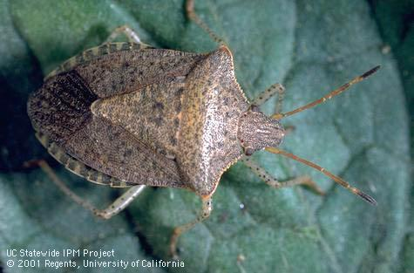

Consperse stink bug

Stink bug monitoring can be difficult because they tend to aggregate, and the distribution within a field may be highly concentrated, particularly along borders. They can be difficult to see even though they are relatively large insects. Most stink bugs thresholds are based on drop cloth samples and on the occurrence of internal symptoms of feeding damage to bolls, rather than on visual or sweep net sampling.

The drop cloth method calls for a treatment when one or more stink bugs are found per drop cloth sample (6 row feet) or when 20 percent or more of thumb-sized bolls show internal evidence of stink bug feeding, including feeding warts or stained lint. Sweep net sampling is not an efficient way to monitor for stink bugs, because they feed on bolls on the bottom portion of the plant. However, when using a sweep net for sampling for lygus bugs, also monitor for stink bugs, especially along the edge of the field closest to crop or weed hosts such as alfalfa grown for seed. Prior to making stink bug treatment decisions based on sweep samples, sample 100 bolls (25 per field quadrant) for evidence of stink bug damage, and treat when 2 or more stink bugs are found in 100 sweeps and there is 10 to 15 percent stink bug damage found in the bolls.
High May Temperatures Lead to Abnormal June Cotton Flowers

Michael Rethwisch

Examination of low desert area cotton flowers has revealed that a great majority of the cotton flowers opening the period June 17-20 were abnormal as a result of heat stress. Symptoms of heat stress on cotton flowers include an elongated stigma (extending beyond the anthers and pollen), smaller cotton flowers, little to no pollen shed, and poor pollen and ovule viability. As it is not uncommon to note these abnormalities in mid- to late summer cotton flowers following a high heat event, it is very unusual to experience them in early season cotton flowers.

While early June temperatures have been quite comfortable, high temperatures of 110º F on May 21 and 22 were recorded in the Blythe area. These high temperatures were a very rapid heat increase from the high 80s and low 90s temperatures experienced in the days/weeks prior to these dates. Low temperatures also jumped from the mid to upper 50s to low night temperatures of 69 and 70º F on May 23 and 24 respectively. These high temperatures and related heat stress were being visually expressed as abnormal cotton flowers in mid-June, being especially characterized by elongated stigmas.

Two different cotton variety trials being conducted in the Palo Verde Valley allowed data to be collected during June 17-20, with 100+ flowers per plot examined in each plot (four replications) of each of the 14 cotton variety entries. Every cotton variety had an average of 90+% of flowers expressing heat stress abnormalities (elongated stigma) even though the trials varied by planting date and location. These data indicate that the abnormalities are not limited to certain varieties, and that the varieties are quite

8

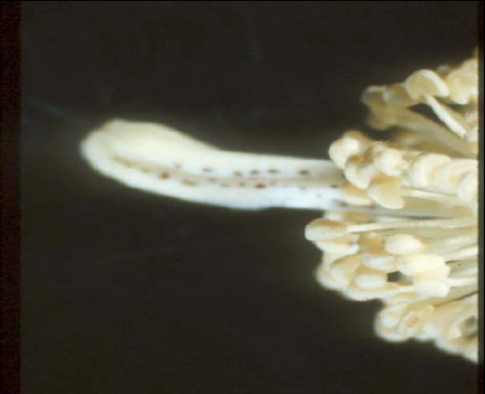
Heat Stressed Cotton Flowers

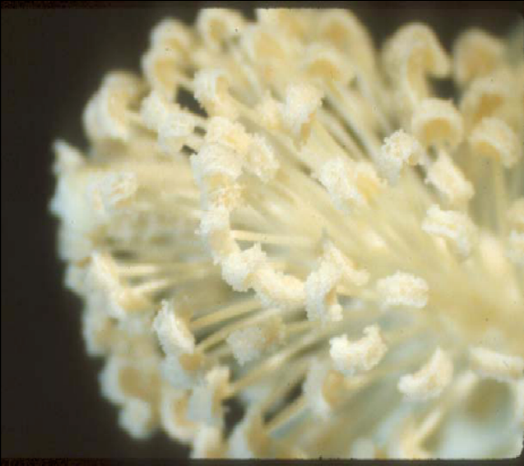

similar in their response to heat stress at this particular time in their development.

Slightly higher percentages of abnormal flowers were noted on June 20 than on June 17-18 which may indicate that these effects are increasing in severity for a period of time longer than the initial heat stress period, however these data are also from different fields. The length of time that the heat stress event affects development of flowers is unknown, but appears to be at least 7 days in duration. Effects on potential bolls from these flowers are yet to be determined.

CIMIS REPORT

Khaled Bali and Steve Burch*

California Irrigation Management Information System (CIMIS) is a statewide network operated by California Department of Water Resources. Estimates of the daily reference evapotranspiration (ET_{o}) for the period of July 1 to September 30 for three locations in the Imperial County are presented in Table 1. ET of a particular crop can be estimated by multiplying ET_{o} by crop coefficients. For more information about ET and crop coefficients, contact the UC Imperial County Cooperative Extension Office (352-9474) or the IID, Irrigation Management Unit (339-9082). Please feel free to call us if you need additional weather information, or check the latest weather data on the worldwide web (visit http://tmdl.ucdavis.edu and click on the CIMIS link).

Table 1.Estimates of daily Evapotranspiration (ET_{o}) in inches per day
Station | July |  | August |  | September
Station | 1-15 | 16-31 | 1-15 | 15-31 | 1-15 | 16-30
Calipatria | 0.39 | 0.38 | 0.35 | 0.32 | 0.30 | 0.27
El Centro (Seeley) | 0.38 | 0.37 | 0.32 | 0.29 | 0.29 | 0.26
Holtville (Meloland) | 0.39 | 0.38 | 0.34 | 0.31 | 0.30 | 0.27
* Irrigation Management Unit, Imperial Irrigation District.

To simplify our information it is sometimes necessary to use trade names of products or equipment. No endorsement of named products is intended nor is criticism implied of similar products, which are not named

Eric T. Natwick, County Director
9

