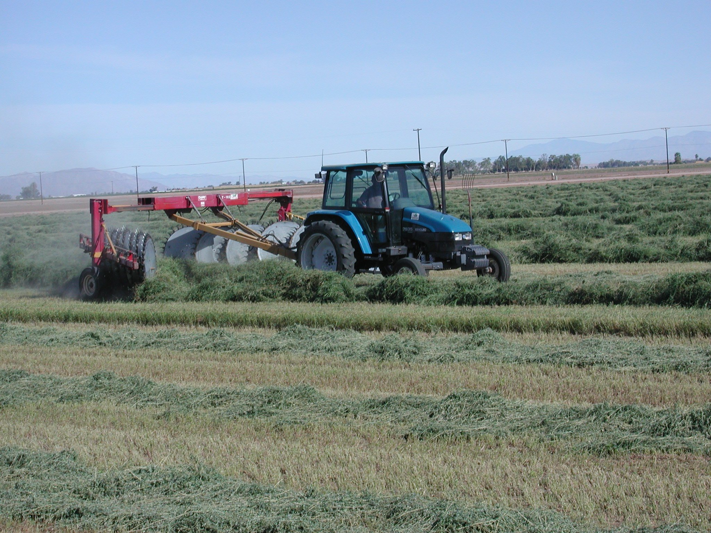
Imperial County
Agricultural Briefs
Features

December 2005

 | Page
TARPING WINTER HAY …………………………................................… Juan N. Guerrero | 2
CORKY ROOT OF LETTUCE ………………………………………....... Thomas A. Turini | 4
BIOTECHNOLOGY SENSITIVITY………………….…………...……… Juan N. Guerrero | 5
EVALUATION OF INSECTICIDES FOR CONTROL OF EGYPTIAN ALFALFA WEEVIL ………………………………………………………………………. Eric T. Natwick | 7
ANNOUNCEMENTS AND MEETING REMINDER ………………………………………. | 8
CIMIS REPORT ..........................................................................Khaled Bali and Steve Burch | 9

Tarping Winter Hay

Juan N. Guerrero

Now that the hot weather has abated and the winter rainy season (as it is in the desert) starts, in order to protect stacked hay from the elements, several measures may be taken. December is the rainiest month of the year, the long-term mean monthly precipitation for December being 0.52 in. The long-term mean monthly rainfall for January is 0.42 in. Storing alfalfa hay during rainy periods is a problem that all growers must resolve. Remember, during February and March, quality dairy hay is usually in short supply, and any grower that has quality hay during this critical period may benefit. Top bales from uncovered stacked hay often become wet and mold during the winter, and much hay often has to be thrown away or be sold at a lower price because it is rain-damaged.

One method of storing alfalfa hay throughout the US during rainy periods is to place the hay in hay barns. Some local producers, indeed, do have hay storage barns to protect valuable alfalfa hay. Unfortunately, most local alfalfa growers do not have hay barns for protecting alfalfa hay quality during rainy periods. Barn-stored or tarped hay is worth money. The best objective source of local hay prices, in my humble opinion, is the federal Agricultural Marketing Service. For information regarding local hay prices I go on-line to http://www.ams.usda.gov/mnreports.ML_GR311.txt . At the last part of the report, Imperial FOB hay prices are reported. Barn/Tarp hays have special lines, and usually (if you take note) have higher prices.

Plastic tarps may be used to protect hay quality during inclement weather. During rainy periods, with uncovered hay, the top level of hay bales in the stack is exposed to rainfall and often during the winter turns black with mold. Covering winter hay with a plastic tarp is a cheap way to conserve both hay quality and hay yield.

There are several methods used to tarp hay. I am unaware of any scientific data regarding different tarping methods. Some growers only tarp top bales, leaving the rest of the stack exposed. Other growers tarp the top ½ of the stack (Figure 1). Still, other growers tarp the entire stack, covering even the bottom bales. Since rainfall does not always fall at a 90° angle, I would advise covering at least the top ½ of the hay stack (covering all the way down, in my opinion, is better). The plastic tarp should also be securely tied down to the stack so that it doesn’t blow away. Protecting winter hay with plastic tarps not only prevents mold growth but prevents bleaching as well. Yes, even during the winter, exposed hay will bleach. Green, soft, hay in February and March, is highly valued by the dairyman. Moldy hay for horses should be specially avoided, ruminants are more tolerant.
Plastic tarps come in several different colors. I have no advice regarding which color tarps are better than others. In my experience, the plastic should be thick so that it doesn’t tear easily when wind-blown. During very wet weather, even barn-stored or tarped hay, may absorb ground moisture and mold. I am aware that some persons have attempted to place plastic at ground level, but with varying results. I
am unaware if the same plastic tarps that are used during winter are the most appropriate for summer. I have tarped hay for 20 weeks during the summer. For hay baled at 14% moisture in May, after 20 weeks tarped hay still had about 10% moisture; the untarped hay had shrunk to 5% moisture levels. Brittle, dry hay is not the most recommendable hay for livestock. As the winter wet season approaches, tarping valuable hay would be advisable.

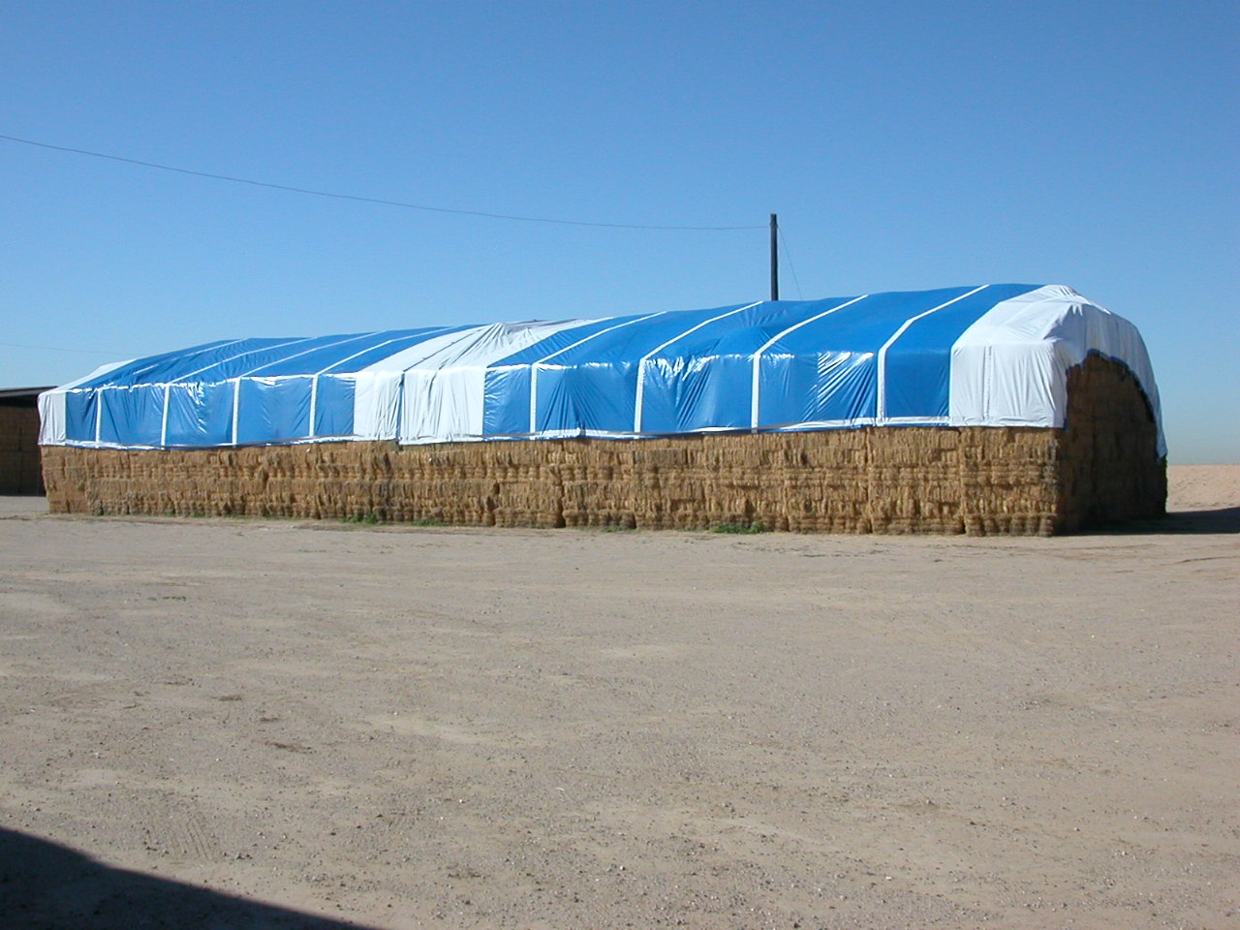

Corky Root of Lettuce


Thomas A. Turini

The disease, corky root, is caused by the soil-borne bacterium, Rhizomonas suberifaciens. It is widespread in costal production areas of California and is present in Imperial County.

Symptoms of this disease begin as yellow lesions on the tap-root and larger laterals. Later, these bands expand and develop a greenish-brown rough appearance and longitudinal corky ridges are apparent. The center portion of the root may become brown and hollow. When the disease is severe, roots become brittle and may be pinched off.

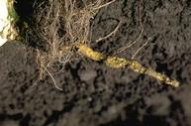
This disease will reduce plant size. Reductions by 30 to 70% have been reported. The disease tends to be more severe when soil temperatures are high. Between 50º and 87ºF, growth of R. suberifaciens increases with increases in temperature. Over 97ºF, growth ceases.

The disease is worse in fields where lettuce is grown during consecutive seasons. Leaf and head lettuce types are susceptible and the host range includes endive, sowthistle and prickly lettuce. Rotating away from lettuce and controlling susceptible weeds may decrease the chances that this will become a problem.

There has been recent work in development of corkyroot-resistant varieties. Three currently available romaine varieties that are resistant are Clemente, Outback, and Siskiyou.

It is important to carefully monitor for this disease this season as the presence of this pathogen in a field can cause substantial losses to next seasons crop. If it is detected, rotate out of lettuce or plant resistant varieties.

Biotechnology Sensitivity

Juan N. Guerrero

On Oct. 4, there was a meeting at the Farm Bureau, where various UC researchers talked about stewardship and biotech alfalfa. Dr. Dan Putnam spoke about the sensitivity of certain market sectors that might be sensitive (negative) about biotech alfalfa. Forage Genetics/Monsanto have recently announced that glyphosate-resistant, i.e. Roundup® ready, alfalfa will be available this fall.
There are already numerous biotechnology (genetically modified organisms, GMO) products commercially available. Corn, cotton, soybeans, wheat, and rice have biotech seeds available and are already planted on thousands of acres. Insulin and blood-clot prevention medications are produced by biotechnology (i.e. gene manipulation). Any child in the US that has drunk milk, has been a recipient of biotechnology. The scientific literature has many examples of farm animals; cattle, hogs, and poultry, that have been fed biotech crops. The carcasses of these animals have been ground up, and the gene sequences of the carcasses were determined; none of the genes introduced into the biotech crop have ever been incorporated into mammalian bodies; biotech products are safe for humans.
There are however sectors of the society that are vehemently opposed to GMO’s in our food supply. There are those that claim that only organically produced food is safe. For example, an organic dairy would be limited to organically grown

feedstuffs for the cows. Although there many claims as to the phenomenal growth of organically produced foods, organic milk is less than 1% of US milk production. Dairies commonly use about 75% of all the alfalfa grown in California. Dairies are already very dependent on GMO’s, most milk in the US is produced with the assistance of Bovine Somatotropin, produced by biotechnology methods. The dairy industry, the principal user of alfalfa hay, would not be sensitive to GMO alfalfa.
Other than Texas, California has the largest number of horses in the nation, about 650,000, principally kept as pets rather than as farm work animals. The adage of the retail business; “The customer is always right;” certainly applies to horse nutrition. Color, smell, anecdote, and hearsay are often the main determinants for alfalfa hay purchases by horse owners. Most horse owners do not use the services of professional animal nutritionists. Using scientifically based nutritional information (I’ve tried) for horse owners is often not productive. Alfalfa hay purchase by the horse trade is capricious. This sector however does buy from 5 to 15% of the alfalfa grown in California. It would be difficult to quantify the sensitivity this market sector to GMO alfalfa. However, horses are quite sensitive to the presence of weedy hay, and a reduced level of weeds in hay for horses would probably be quite welcome by horse owners.
Certain foreign markets ban the importation of GMO crops. The EU and Japan limit the importations of GMO crops. Little, if any, alfalfa products from California are sold to the EU. Pellets, cubes, and compressed alfalfa hay does enter Japan from California. Any person selling hay products to Japan must take great measures to assure the Japanese customers that no GMO’s are contained in exported alfalfa. Of the total alfalfa production of California, only about 1% is exported to Japan! If you are in an area that does export alfalfa hay to Japan, the introduction of GMO hay would certainly be of great concern.

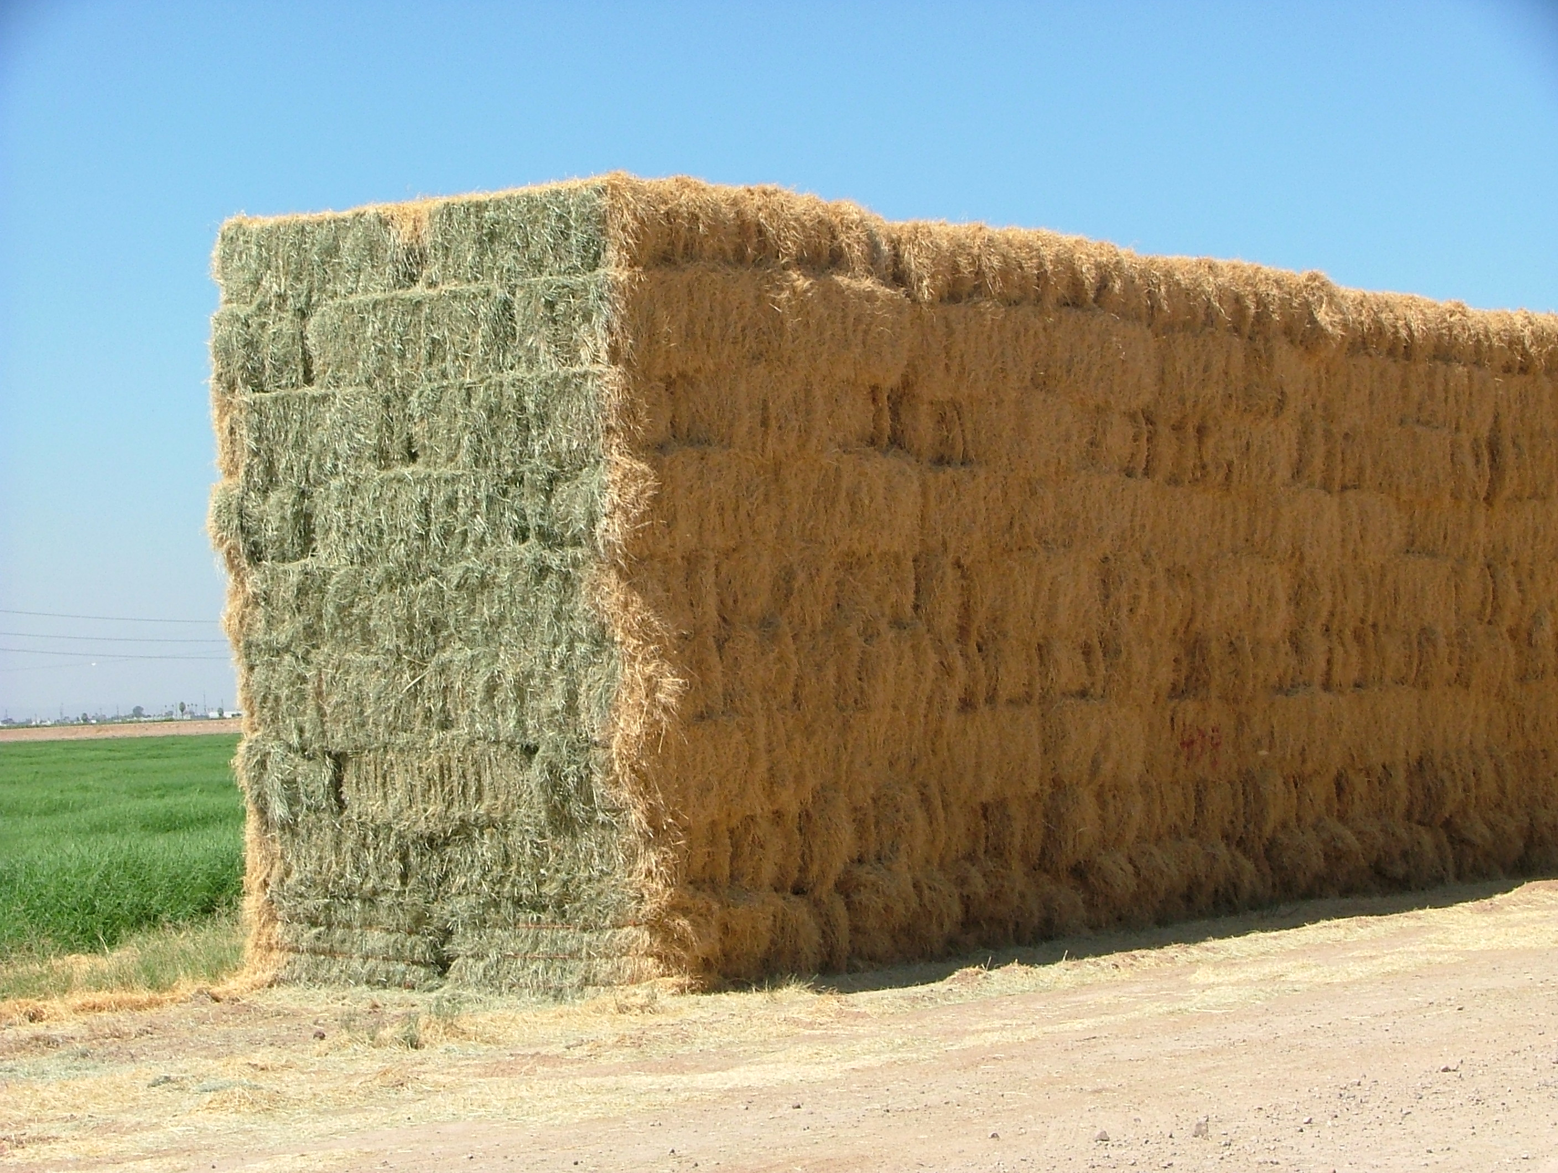

GMO crops are here to stay. The use of GMO crops presents the potential for less pesticide use, certainly advantageous environmentally. Any business person must know the market in which he will operate, a farmer is no different. The market sector that will be sensitive to GMO alfalfa will be less than 3% of the total market.

Evaluation of Insecticides for Control of Egyptian Alfalfa Weevil


Eric T. Natwick

A field study was conducted during the spring of 2005 at the UC Desert Research and Extension Center. A stand of alfalfa, VAR. CUF 101, was used for the experiment. Plots were arranged in a randomized complete block design with four replications. Nine insecticide treatments were included along with an untreated control. Insecticide treatments and rates are listed in Table 1. Plots measured 35 feet by 50 feet and insecticide treatments were applied March 14, 2005, using a broadcast application with a tractor mounted boom.

Egyptian alfalfa weevil (EAW) larval populations were measured in each plot with a standard 15-inch diameter insect net consisting of ten, 180º sweeps. Plots were sampled on March 11, 16, 21, & 28, 2005; 3-day pre-treatment (DPT), 2-days after treatment (DAT), 7-DAT, and 14-DAT.

No differences were found among the treatments for EAW larvae in the pre-treatment samples, (P>0.05), Tables 1. All of the insecticide treatments controlled Egyptian alfalfa weevil with larval means that were significantly lower (P0.05) than the untreated control treatment means from 2-DAT through 14-DAT.

Table 1. Mean Numbers^{v} of Egyptian Alfalfa Weevil Larvae per Ten Sweeps, Holtville, CA, 2005.
Treatment | oz/acre | PT^{w} | 2 DAT^{x} | 7 DAT^{y} | 14 DAT | PTM^{yz}
Untreated | -------- | 40.75 a | 49.75 a | 12.00 a | 2.25 a | 21.33 a
Mustang 1.5 EW + COC | 4.3 fl +  1% v/v | 27.25 a | 1.00 b | 0.25 c | 0.00 b | 0.42 d
Mustang 1.5 EW + Furadan 4F +  COC | 4.3 fl+  4.0 fl  1% v/v | 49.50 a | 1.50 b | 0.50 bc | 0.00 b | 0.67 cd
Mustang Max 0.8 EW | 4.0 fl | 56.50 a | 0.5 b | 0.00 c | 0.00 b | 0.17 d
Warrior 1 EC + COC | 3.2 fl +  1% v/v | 41.00 a | 4.5 b | 1.50 bc | 0.25 b | 2.08 bcd
Warrior 1 EC + COC | 3.5 fl +  1% v/v | 52.25 a | 0.75 b | 1.75 bc | 0.25 b | 0.92 bcd
Proaxis + 0.497 CS  COC | 3.2 fl +  1% v/v | 79.25 a | 2.25 b | 2.25 b | 1.00 ab | 1.83 bc
Steward 1.25 SC + Lorsban 4E | 4.6 fl +  4.0 fl | 78.75 a | 2.75 b | 0.25 c | 0.00 b | 1.00 bcd
Imidan 70W + Dimethoate 267E | 16.0 dry + 18.0 fl | 68.50 a | 7.00 b | 0.50 bc | 0.25 b | 2.58 b
Furadan 4F | 16.0 fl | 66.50 a | 1.00 b | 0.25 c | 0.00 b | 0.42 d

^{v} Mean separations within columns by LSD_{0.05}.
^{w} Pre-treatment.
^{x} Days after treatment.
^{y} Log transformed data used for analysis; true means reported.
^{z} Post treatment means


ANNOUNCEMENTS AND REMINDERS

MARK YOUR CALENDARS!
Tuesday, November 29, 2005

IRRIGATION SCHEDULING WORKSHOP

Held at Barbara Worth Golf Resort and Convention Center

8:30 AM – 12:00 PM (workshop in English)

1:30 PM – 4:30 PM (workshop in Spanish)

Topics to be covered
Basics of Evapotranspiration
Reference Evapotranspiration (ETo)
California Irrigation Management Information System (CIMIS)
Plant Water Use and Crop Coefficients
Water Budget Scheduling with Basic Irrigation Scheduling (BIS) Program
Registration Fee: Free
Workshop materials and Computer CD will be available for you if you register prior to November 28, 2005. Please email or fax your name and contact information to Khaled Bali (email:kmbali@ucdavis.edu or Fax 760-352-0846). You may bring your notebook computer for hands on Irrigation Scheduling using the BIS program; however, a computer is not necessary to attend the workshop.

If you need special accommodations, please contact us at 760-352-9474

CIMIS REPORT

Khaled Bali and Steve Burch*

California Irrigation Management Information System (CIMIS) is a statewide network operated by California Department of Water Resources. Estimates of the daily reference evapotranspiration (ET_{o}) for the period of December 1 to February 28 for three locations in the Imperial County are presented in Table 1. ET of a particular crop can be estimated by multiplying ET_{o} by crop coefficients. For more information about ET and crop coefficients, contact the UC Imperial County Cooperative Extension Office (352-9474) or the IID, Irrigation Management Unit (339-9082).

Please feel free to call us if you need additional weather information, or check the latest weather data on the worldwide web (visit http://tmdl.ucdavis.edu and click on the CIMIS link).

Table 1. Estimates of daily Evapotranspiration (ET_{o}) in inches per day
Station | December |  | January |  | February
Station | 1-15 | 16-31 | 1-15 | 15-31 | 1-15 | 16-28
Calipatria | 0.07 | 0.07 | 0.08 | 0.09 | 0.12 | 0.14
El Centro (Seeley) | 0.06 | 0.06 | 0.08 | 0.09 | 0.12 | 0.14
Holtville (Meloland) | 0.06 | 0.06 | 0.08 | 0.09 | 0.12 | 0.14

* Irrigation Management Unit, Imperial Irrigation District.




